**ITE3714: Multimedia Website Design Practices**

# **Lab 2 – Font, Hyperlink and Multimedia elements in HTML**

1. Create a folder named **lab2** in Desktop
2. Download **"lab2_student.zip"** from Moodle
3. Unzip **"lab2_student.zip"** and put it in folder **lab2**
4. Open **"lab2_student.html"** using Notepad++ and Google Chrome
5. In the **<body>** tag, add the attributes **bgcolor="#FCF3CF"**

|  |
| --- |
| <body bgcolor="#FCF3CF"> |

1. Open **"lab2_student.html"** in Google Chrome and see the result
2. In the **<body>** tag, replace the attribute to **background="background.jpg"**

|  |
| --- |
| <body background="background.jpg"> |

After the **<body>** tag, do the following:

1. Add the following commenttag

|  |
| --- |
| <!-- Lab 2 -->  <! Lab 2 > |

1. Add 2 **<br>** tags for better looking

|  |
| --- |
| <br><br> |

**(Note: for the remaining steps, you need to add 2 <br> tag)**

1. Add a pair of **<font>** tag to the text **"Institute of Vocational Education"**

|  |
| --- |
| <font size="6" color="DarkBlue" face="Arial">Institute of Vocational Education</font>  <br><br> |

1. Add an **<img>** tag after **<br>** bag

|  |
| --- |
| <img src="ive_logo.jpg" height="200" width="200">  <br><br> |

1. Add a pair of **<marquee>** and **<font>** tag to the text **"Admission for Academic Year 2018-19 is open!"**

|  |
| --- |
| <font size="4"><marquee behavior="alternate" direction="Left" loop="-1">Admission for Academic Year 2018-19 is open!</marquee></font>  <br><br> |

1. Add a pair of **<a>** tag to the text **"Click me to apply"**

|  |
| --- |
| <a href="http://www.vtc.edu.hk">Click me to apply</a>  <br><br> |

1. Add a pair of **<a>** tag and **<img>** tag after the **<br>** tag

|  |
| --- |
| <a href="http://www.vtc.edu.hk"><img src="apply_now.jpg" height="200" width="500"></a>  <br><br> |

1. Add a pair of **<audio>** tag after the **<br>** tag

|  |
| --- |
| <audio controls autoplay loop>  <source src="cheers.mp3" type="audio/mpeg">  </audio>  <br><br> |

1. Add a pair of **<video>** tag after the **<br>** tag

|  |
| --- |
| <video width="640" height="480" controls>  <source src="promotion.mp4" type="video/mp4">  </video> |

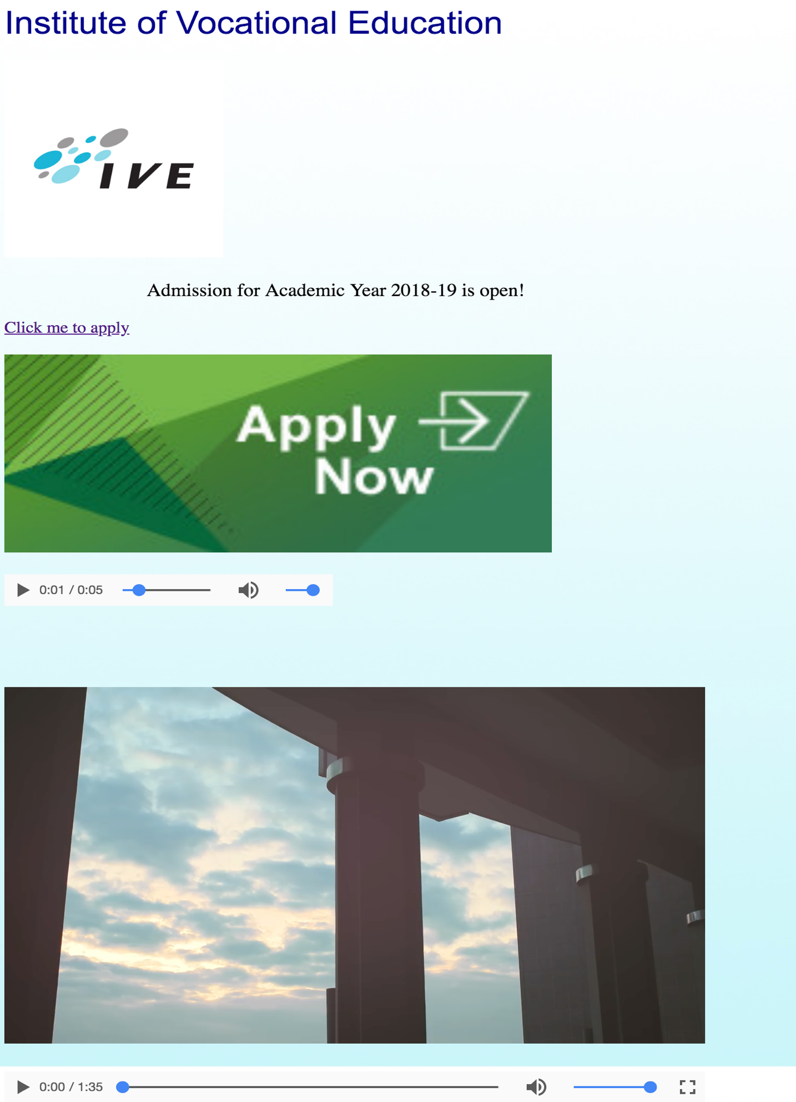

Source Codes for Reference:

